# Weekly Report – 30.04.2018

## Oscilloscope Probes

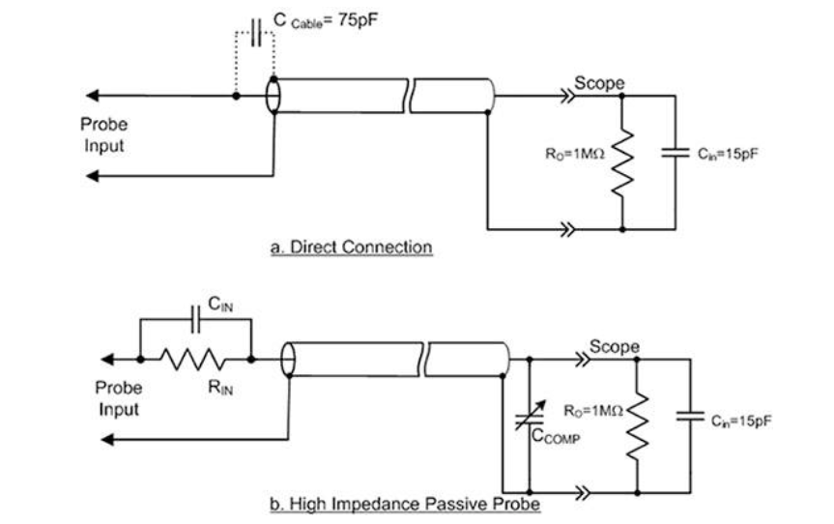

Figure : Probe Circuits

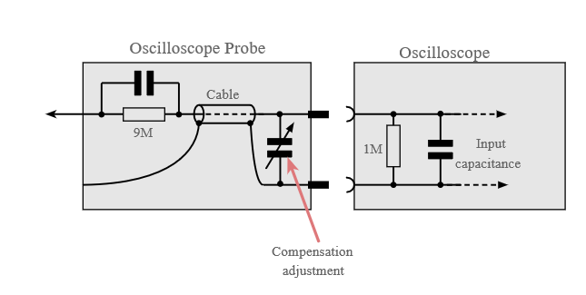

Figure : 10x Probe Circuit

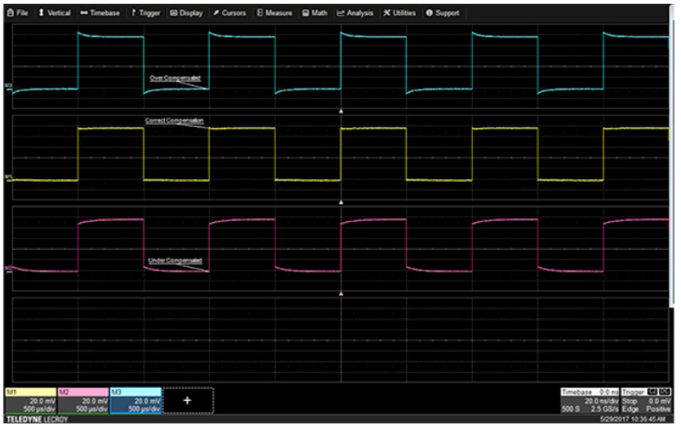

Figure : Compensation Adjustment

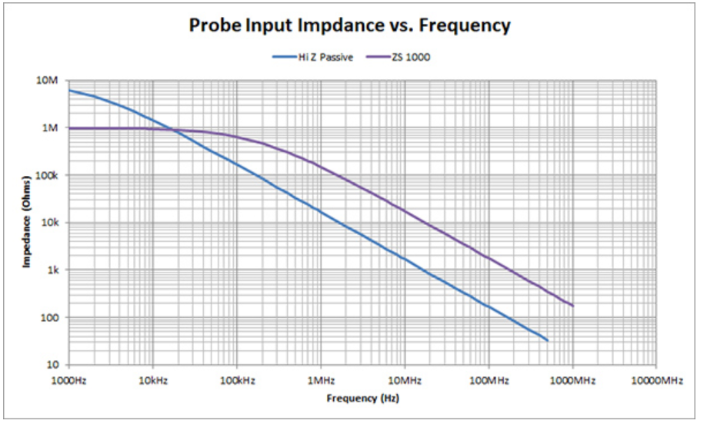

Figure : Active Probe(Purple) vs Hi Z(10x) Probe(Blue)

## How we burned EVM

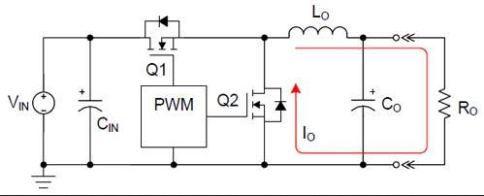

Figure : Synchronous Buck Converter

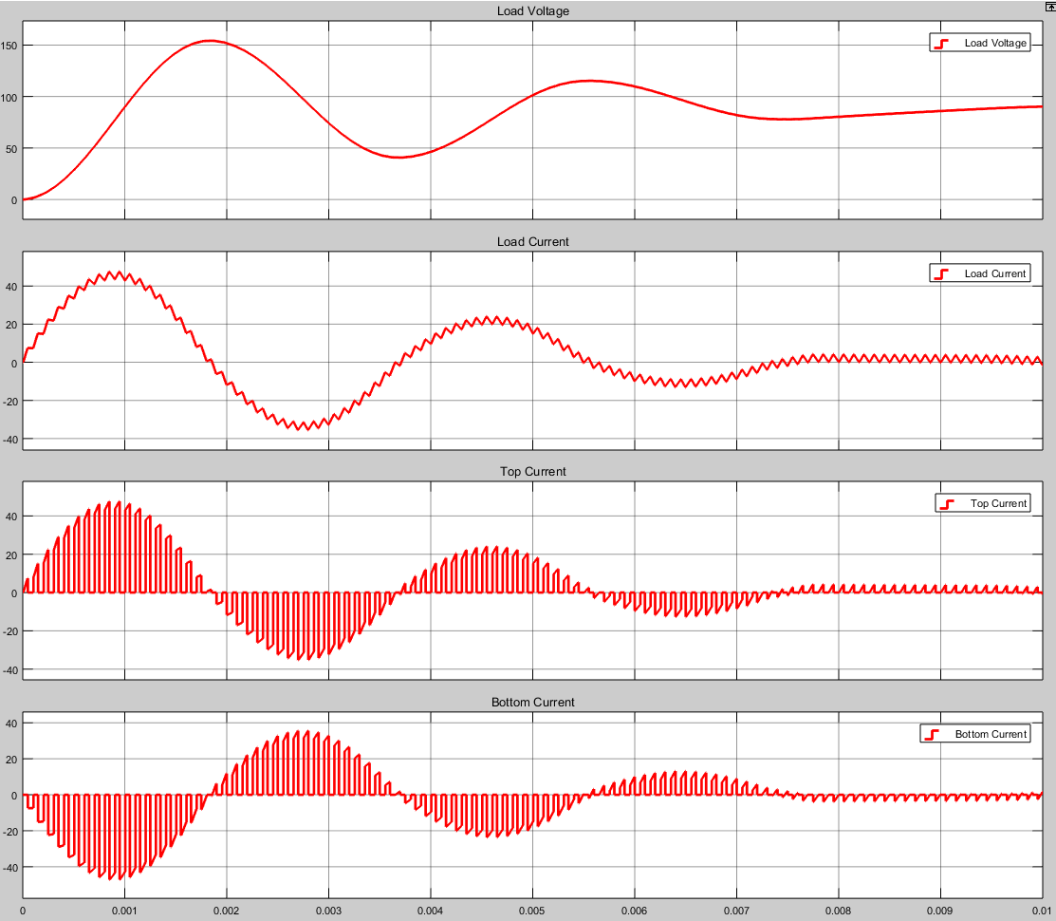

Figure : Load Current & Voltage and Switch Currents